Semester Two Examination, 2022
Insert School Logo
Insert School Logo
Question/Answer Booklet

HUMAN BIOLOGY
UNITS 1 & 2

Name: __________________________________________________________

Teacher: ______________________________________________________

Time allowed for this paper

Reading time before commencing work: ten minutes
Working time for the paper: three hours

Materials required/recommended for this paper
To be provided by the supervisor
This Question/Answer Booklet
Multiple-choice Answer Sheet

To be provided by the candidate
Standard items: pens (blue/black preferred), pencils (including coloured), sharpener, correction fluid/tape, eraser, ruler, highlighters

Special items: up to three calculators, which do not have the capacity to create or store programmes or text, are permitted in this ATAR course examination

Important note to candidates
No other items may be taken into the examination room. It is your responsibility to ensure that you do not have any unauthorised material. If you have any unauthorised material with you, hand it to the supervisor before reading any further.
Structure of this paper

Section | Number of questions available | Number of questions to be answered | Suggested working time (minutes) | Marks available | Percentage of examination
Section One Multiple-choice | 30 | 30 | 40 | 30 | 30
Section Two Short answer | 7 | 7 | 90 | 108 | 50
Section Three Extended answer  Unit 1 | 2 | 1 | 50 | 20 | 10
Unit 2 | 2 | 1 |  | 20 | 10
 |  |  |  | Total | 100
Instructions to candidates

1. The rules for the conduct of the Western Australian examinations are detailed in the Year 12 Information Handbook 2022: Part II Examinations. Sitting this examination implies that you agree to abide by these rules.

2. Write your answers in this Question/Answer booklet preferably using a blue/black pen. Do not use erasable or gel pens.

3. Answer the questions according to the following instructions.

Section One: Answer all questions on the separate Multiple-choice answer sheet provided. For each question, shade the box to indicate your answer. Use only a blue or black pen to shade the boxes. Do not use erasable or gel pens. If you make a mistake, place a cross through that square, then shade your new answer. Do not erase or use correction fluid/tape. Marks will not be deducted for incorrect answers. No marks will be given if more than one answer is completed for any question.

Section Two: Write your answers in this Question/Answer booklet. Wherever possible, confine your answers to the line spaces provided.

Section Three: Consists of two parts each with two questions. You must answer one question from each part. Tick the box next to the question you are answering. Write your answers in this Question/Answer booklet.

4. You must be careful to confine your answers to the specific questions asked and to follow any instructions that are specific to a particular question.

5. Supplementary pages for planning/continuing your answers to questions are provided at the end of this Question/Answer booklet. If you use these pages to continue an answer, indicate at the original answer where the answer is continued, i.e. give the page number.

Section One: Multiple–choice 30% (30 Marks)

This section has 30 questions. Answer all questions on the separate Multiple-choice answer sheet provided. For each question, shade the box to indicate your answer. Use only a blue or black pen to shade the boxes. Do not use erasable of gel pens. If you make a mistake, place a cross through that square, then shade your new answer. Do not erase or use correction fluid/tape. Marks will not be deducted for incorrect answers. No marks will be given if more than one answer is completed for any question.

Suggested working time: 40 minutes.

1. Follicle stimulating hormone is released from the

(a) ovaries.
(b) testes.
(c) corpus luteum.
(d) pituitary gland.

Questions 2, 3 and 4 refer to the following information.

Sahan is studying microscopy in class, using a light microscope with a 10x ocular lens to view various samples of human body cells. The first sample he observes is a slide of epithelial cells taken from the lining of the duodenum, viewed at a total magnification of 400x.

2. Which of the following objective lenses is Sahan using to view the slide of epithelial cells?

(a) 10x
(b) 40x
(c) 4x
(d) 400x

3. If one of the epithelial cells in the sample takes up approximately one fifth of the diameter of the field of view, which is 0.46 mm at this magnification, what is the approximate size of the cell in millimetres?

(a) 92 mm
(b) 0.092 mm
(c) 2.3 mm
(d) 2300 mm

4. Which of the following correctly states the diameter of the field of view, in micrometres, if the microscope was changed to 1000x total magnification?

(a) 460 µm
(b) 0.184 µm
(c) 184 µm
(d) 115 µm

5. A Pap smear is a test that can be used to identify abnormal cells that could lead to the development of

(a) cervical cancer.
(b) prostate cancer.
(c) bowel cancer.
(d) breast cancer.

6. An imbalance in the action of osteoblasts and osteoclasts can most likely lead to the onset of which of the following disorders?

(a) osteoarthritis
(b) bone cancer
(c) osteoporosis
(d) rheumatoid arthritis

7. Which of the following correctly describes the importance of informed consent when carrying out an investigation involving human trials?

(a) Everyone has the right to have their identities kept confidential.
(b) Everyone has the right to know the possible risks, potential benefits and the objectives of the investigation.
(c) Nobody should be pressured into taking part in the investigation.
(d) Everyone has the right to remain anonymous throughout the investigation.

8. After a 12-week ultrasound a young couple were informed that there was a high probability of their baby being born with a chromosomal abnormality. The couple decided to get a diagnostic test to allow them to be better informed and prepared for the outcome at birth. Which of the following tests would the couple be able to get at this week of the pregnancy?

(a) chorionic villus sampling
(b) fetoscopy
(c) preimplantation genetic testing
(d) amniocentesis

9. Athletes have an increased risk of wearing away the cartilage found on the epiphyses of the bone that allow for smooth, frictionless movement. This can lead to a condition known as

(a) rheumatoid arthritis.
(b) spondyloarthritis.
(c) osteoarthritis.
(d) bursitis.

10. Which of the following correctly describes a difference between the processes of spermatogenesis and oogenesis?

(a) Spermatogenesis produces 4 mature haploid cells while oogenesis produces 1 mature haploid cell.
(b) Spermatogenesis occurs in the interstitial cells of the testes while oogenesis occurs in the ovaries.
(c) Spermatogenesis produces 4 haploid cells while oogenesis produces 1 diploid cell.
(d) Spermatogenesis produces polar bodies while oogenesis does not.

11. The outer layer of cells that spermatozoa break through in order to enter the cytoplasm of the ovum is known as the

(a) corpus luteum.
(b) zona pellucida.
(c) acrosome.
(d) corona radiata.

12. A man with Huntington’s disease and a woman without Huntington’s have two children. After genetic testing it is determined that one of their children will develop Huntington’s when they’re older, while the other is genetically healthy. What is the percentage probability of the couple having another child with Huntington’s disease?

(a) 25%
(b) 75%
(c) 50%
(d) 100%

13. The following points describe the steps, out of order, in the sliding filament model that explains the contraction of skeletal muscles from the point where the muscle cells are stimulated by a nerve cell.

(i) Myosin heads bind to actin forming a myosin cross-bridge
(ii) The myosin head bends and ADP and phosphate are released, pulling the actin over the myosin
(iii) Calcium ions enter the muscle cells and the presence of calcium exposes the myosin binding sites on the actin molecule
(iv) A new molecule of ATP attaches to the myosin and the cross-bridge detaches

Which of the following indicates the steps in the correct order?

(a) (i), (ii), (iii), (iv)
(b) (iii), (i), (iv), (ii)
(c) (i), (iii), (iv), (ii)
(d) (iii), (i), (ii), (iv)

Questions 14, 15 and 16 refer to the following diagram of the human male reproductive system.

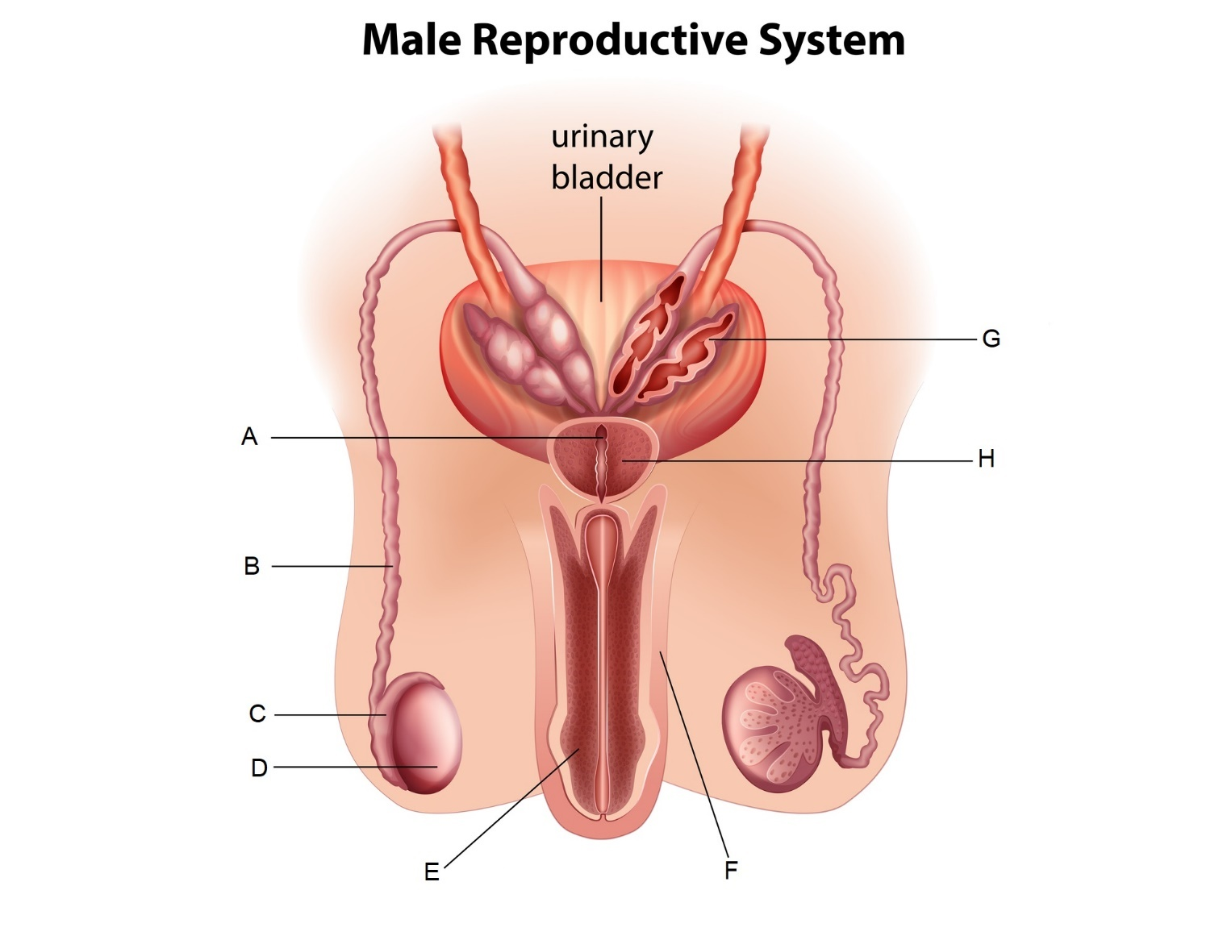

14. Which of the following labels indicates the epididymis?

(a) A
(b) B
(c) C
(d) D

15. Which of the following most correctly describes the function of the part labelled H?

(a) It secretes a fluid rich in sugars that makes up the majority of the seminal fluid.
(b) It secretes a small amount of fluid that acts as a lubricant.
(c) It secretes an alkaline fluid that helps to neutralise the acidity in the vagina.
(d) It secretes a fluid rich in proteins to provide spermatozoa with strength for swimming.

16. A relatively simple surgical procedure to sterilise males and prevent conception usually involves which of the following parts?

(a) A
(b) B
(c) C
(d) D

17. Fertilisation typically takes place in the

(a) ovaries.
(b) cervix.
(c) uterus.
(d) uterine tubes.

18. Which of the following does not describe a structure of the alveoli that make them suited to the process of gas exchange?

(a) The alveoli are one-cell thick.
(b) The alveoli contain approximately 21% oxygen concentration from inhaled air.
(c) The alveoli are surrounded by a rich supply of blood capillaries.
(d) The alveoli are surrounded by a thin layer of moisture.

Questions 19, 20 and 21 refer to the following information.

Deidre and Georgina are conducting an investigation to see the change in mass of cylinders of potatoes when placed in varying concentrations of sucrose solutions. They find that when the potatoes are placed in distilled water they tend to increase in mass, while those placed in concentrated sucrose solutions tend to decrease in mass.

19. Which of the following correctly identifies the dependent variable in this investigation?

(a) the concentration of sucrose
(b) the change in mass of the potato
(c) the volume of sucrose solution
(d) the final mass of the potato

20. If one cylinder of potato in a highly concentrated sucrose solution has an initial mass of 1.55 g and a final mass of 1.44 g, which of the following correctly states the percentage change in mass?

(a) 11% increase
(b) 7% increase
(c) 11% decrease
(d) 7% decrease

21. Which of the following best explains why the potatoes in distilled water increased in mass?

(a) The sucrose moved into the potato through diffusion to balance out the concentration of sucrose in the potato and the distilled water.
(b) The distilled water had a higher solute concentration than the potato, so the water moved into the cells of the potato through osmosis.
(c) The potato had a higher solute concentration than the distilled water, so the water moved into the cells of the potato through osmosis.
(d) The cells of the potato gained mass as the starch inside was diluted by the distilled water.
22. During the process of flexion at the knee, the hamstring is contracting and the quadriceps are relaxing. Which of the following correctly describes the relationship between these two groups of muscles during this movement?

(a) The hamstring is the agonist while the quadriceps are the antagonists.
(b) The hamstring is the antagonist while the quadriceps are the agonists.
(c) The hamstring is the synergist while the quadriceps are fixators.
(d) The hamstring is the fixator while the quadriceps are synergists.

23. Pairs of homologous chromosomes line up together at the equator during

(a) metaphase.
(b) metaphase I.
(c) metaphase II.
(d) anaphase I.

24. With regards to inheritance of ABO blood groups, which of the following correctly identifies the mode of inheritance for the allele that results in no antigens presenting on the erythrocytes?

- X-linked recessive
(b) X-linked dominant
(c) Autosomal dominant
(d) Autosomal recessive

25. In a healthy, functioning nephron, active reabsorption of glucose mostly occurs in the

(a) proximal convoluted tubule.
(b) renal corpuscle.
(c) loop of Henle.
(d) distal convoluted tubule.

26. Glucose is a relatively large, water-soluble molecule that cells consistently use up during the process of cellular respiration. Glucose would most likely pass through the cell membrane through which of the following processes?

(a) osmosis
(b) simple diffusion
(c) facilitated diffusion
(d) active transport

27. Which of the following embryonic membranes will eventually form the foetal portion of the placenta?

(a) the chorion
(b) the amnion
(c) the yolk sac
(d) the allantois

Question 28 refers to the following diagram showing different types of tissue.

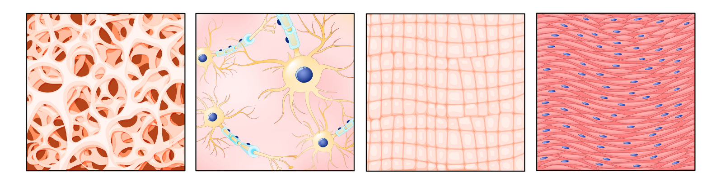

28. Which of the following correctly identifies the types of tissue, from left to right, shown in the diagram above?

(a) connective, nervous, muscular, epithelial
(b) epithelial, nervous, connective, muscular
(c) epithelial, nervous, muscular, connective
(d) connective, nervous, epithelial, muscular

29. After the first meiotic division during oogenesis, one of the cells created is smaller than the other with very little cytoplasm, while the other is larger and contains most of the cytoplasm. These two cells are, respectively, referred to as the

(a) first polar body and secondary oocyte.
(b) first polar body and primary oocyte.
(c) second polar body and secondary oocyte.
(d) second polar body and primary oocyte.

30. Aaliyah has type AB negative blood type and suffers from a blood disorder which requires regular blood transfusions. Which of the following blood types would she not be able to receive in a transfusion?

(a) Type A negative
(b) Type B negative
(c) Type O negative
(d) Type O positive

End of Section One

Section Two: Short answer 50% (108 Marks)

This section has seven questions. Answer all questions. Write your answers in the spaces provided.

Supplementary pages for planning/continuing your answers to questions are provided at the end of this Question/Answer booklet. If you use these pages to continue an answer, indicate at the original answer where the answer is continued, i.e. give the page number.

Suggested working time: 90 minutes.

Question 31 (19 marks)

A group of students were investigating the effect of exercise intensity on tidal volume of the lungs. They measured the tidal volume of five of their classmates at rest and then asked each individual to complete different types of exercise, increasing in levels of intensity, for 4 minutes at a time. Immediately after completing each exercise their tidal volume was then measured with a spirometer and recorded in litres (L).

The data is shown in the table below.

 | Tidal volume (L) after completing 4 minutes of exercise at different intensity levels
Type of Exercise | Individual 1 | Individual 2 | Individual 3 | Individual 4 | Individual 5 | Mean
At rest | 0.50 | 0.61 | 0.48 | 0.49 | 0.56 | 0.53
Walking | 1.21 | 1.10 | 1.16 | 1.18 | 1.42
Jogging | 2.25 | 2.23 | 2.18 | 2.04 | 1.98 | 2.14
Sprinting | 2.68 | 2.73 | 2.38 | 2.80 | 2.67 | 2.65

(a) Outline a possible hypothesis for this investigation. (1 mark)

______________________________________________________________________

______________________________________________________________________

(b) Identify one variable that was controlled during the students’ investigation. (1 mark)

______________________________________________________________________

(c) Complete the table above by calculating the mean tidal volume for ‘Walking’. (1 mark)
(d) Construct a graph of the average tidal volume for each type of exercise, not including the average for when the students were at rest, on the grid provided below. (5 marks)

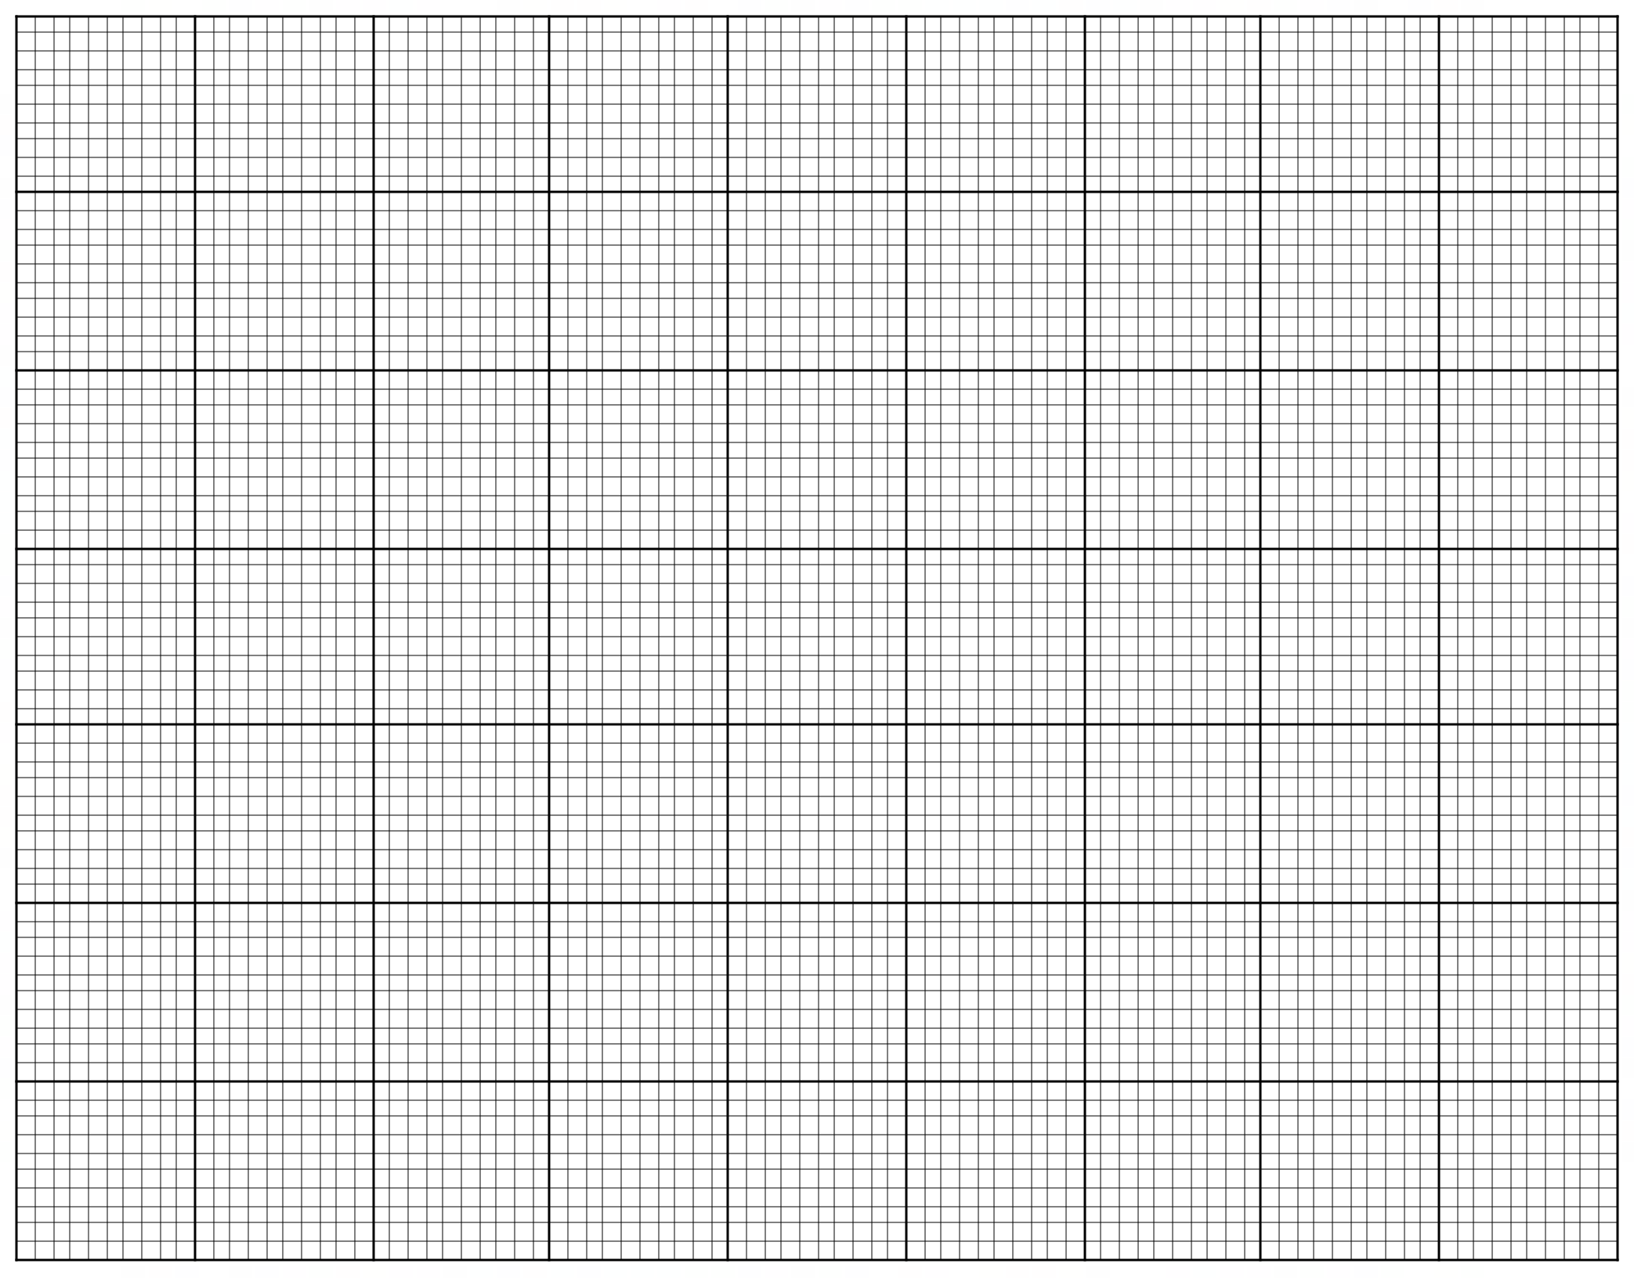

A spare grid is provided at the end of this Question/Answer Booklet. If you need to use it, cross
out this attempt and indicate that you have redrawn it on the spare grid.

(e) Suggest and explain one factor that may have affected the validity of the data.
(2 marks)

______________________________________________________________________

______________________________________________________________________

______________________________________________________________________

______________________________________________________________________

______________________________________________________________________

(f) Tidal volume can be defined as the amount of air moved into the lungs during the process of inspiration. Describe the process of inspiration. (4 marks)

______________________________________________________________________

______________________________________________________________________

______________________________________________________________________

______________________________________________________________________

______________________________________________________________________

______________________________________________________________________

______________________________________________________________________

______________________________________________________________________

The students knew that an increase in the intensity of exercise causes an increase in contractions of the skeletal muscles, which requires the production of adenosine triphosphate (ATP).

(g) State one chemical process that occurs during cellular respiration in the muscle cells that results in the production of ATP. (1 mark)

______________________________________________________________________

The students were able to infer, from their scientific knowledge, that the increase in the tidal
volume of the lungs during exercise will increase the rate of gas exchange between the
blood in the capillaries and the air in the alveoli.

(h) Explain why there would be an increase in the rate of gas exchange as the skeletal muscles start working harder. (4 marks)

______________________________________________________________________

______________________________________________________________________

______________________________________________________________________

______________________________________________________________________

______________________________________________________________________

______________________________________________________________________

______________________________________________________________________

______________________________________________________________________

______________________________________________________________________
Question 32 (12 marks)

The diagram below represents a simplified view of the formation of a blood clot after a blood vessel has been damaged.
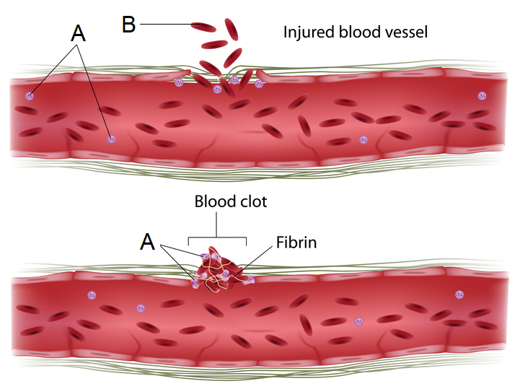

(a) Name the blood cells labelled ‘A’ and ‘B’ in the diagram. (2 marks)

A _______________________________

B _______________________________

A broken blood vessel can lead to an infection of foreign microorganisms. This can stimulate a specific type of blood cell, known as a neutrophil, to consume the microorganisms through phagocytosis, a special form of endocytosis.

(b) Describe the process by which the neutrophil consumes invading microorganisms.
(2 marks)

______________________________________________________________________

______________________________________________________________________

______________________________________________________________________

______________________________________________________________________

______________________________________________________________________

The X-linked genetic condition known as haemophilia means that people are unable to produce
certain clotting factors that result in the production of the meshwork of protein fibres known as fibrin.

The pedigree chart below shows the inheritance of haemophilia in a family.

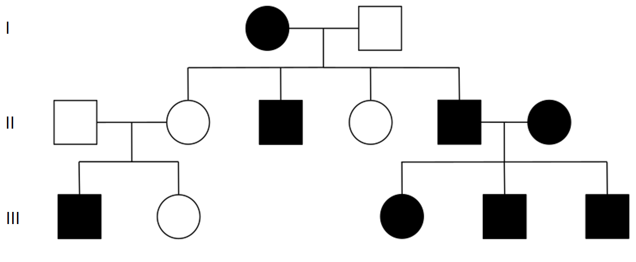

(c) State whether haemophilia is dominant or recessive. Justify your answer using evidence from the pedigree. (2 marks)

______________________________________________________________________

______________________________________________________________________

______________________________________________________________________

______________________________________________________________________

(d) Using the letters N and n, state the genotypes of individual II-2 and II-3. (2 marks)

II-2 _______________

II-3 _______________

(e) Is it possible for the two individuals in generation I to have a son without haemophilia? Explain your answer. (You may use a Punnett square as part of your explanation).
(4 marks)

______________________________________________________________________

______________________________________________________________________

______________________________________________________________________

______________________________________________________________________

______________________________________________________________________

______________________________________________________________________

______________________________________________________________________

______________________________________________________________________

______________________________________________________________________

______________________________________________________________________

Question 33 (17 marks)

The diagram below shows the structures found in the human digestive system.

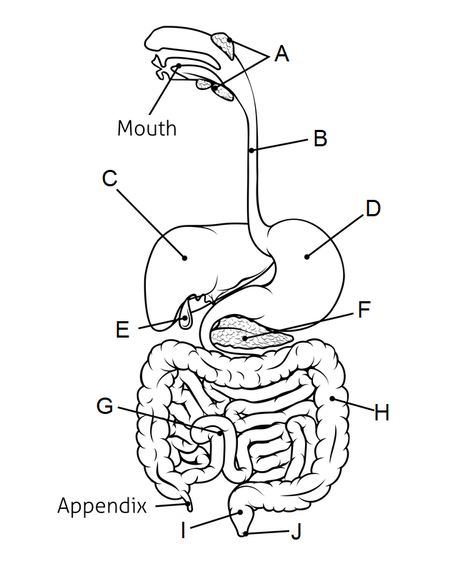

(a) Complete the table below based on the diagram given. (3 marks)

Label | Name of structure
A
B
E

(b) The structure labelled C also plays an important role in metabolic pathways linked to excretion. Name and briefly describe/outline the process that takes place in structure C that leads to the production of urea, a substance excreted by the kidneys. (3 marks)

______________________________________________________________________

______________________________________________________________________

______________________________________________________________________

______________________________________________________________________

______________________________________________________________________

Pancreatic cancer is a type of cancer which can result in the disruption of the normal functioning of the pancreas, which plays an important role in chemical digestion.

(c) Contrast mechanical and chemical digestive processes. (3 marks)

______________________________________________________________________

______________________________________________________________________

______________________________________________________________________

______________________________________________________________________

______________________________________________________________________

______________________________________________________________________

______________________________________________________________________

(d) State which label on the diagram correctly identifies the pancreas. (1 mark)

______________________________________________________________________

(e) Describe what cancer refers to, and explain how the growth of a tumour due to cancer could disrupt the normal functioning of an organ. (3 marks)

______________________________________________________________________

______________________________________________________________________

______________________________________________________________________

______________________________________________________________________

______________________________________________________________________

______________________________________________________________________

______________________________________________________________________

______________________________________________________________________

(f) Pancreatic cancer can lead to, among other things:

Malabsorption – a difficulty in absorbing essential nutrients, and;
Malnutrition – where the cells do not receive enough essential nutrients.

Explain how a dysfunction of the pancreas can cause these conditions. (4 marks)

______________________________________________________________________

______________________________________________________________________

______________________________________________________________________

______________________________________________________________________

______________________________________________________________________

______________________________________________________________________

______________________________________________________________________

______________________________________________________________________

______________________________________________________________________

______________________________________________________________________

______________________________________________________________________

______________________________________________________________________

Question 34 (17 marks)

Proteins are one of the essential nutrients required for the normal functioning of cells and therefore the normal functioning of the entire human body. The production of specialised proteins called enzymes, among other things, also allows for the synthesis of other essential nutrients such as lipids and carbohydrates.

Protein synthesis is a complex process that can be divided into two stages – transcription and translation.

(a) State the name of the cell organelles where each of the stages of protein synthesis takes place. (2 marks)

______________________________________________________________________

______________________________________________________________________

(b) Outline the basic structure of proteins. (2 marks)

______________________________________________________________________

______________________________________________________________________

______________________________________________________________________

(c) Describe the process of transcription. (5 marks)

______________________________________________________________________

______________________________________________________________________

______________________________________________________________________

______________________________________________________________________

______________________________________________________________________

______________________________________________________________________

______________________________________________________________________

______________________________________________________________________

______________________________________________________________________

______________________________________________________________________

______________________________________________________________________

Errors in the DNA code can lead to problems with protein synthesis, which can have a range of effects on normal cell functioning.

(d) Explain the possible effect on metabolism if the enzymes needed for carbohydrate production could not be produced. (3 marks)

______________________________________________________________________

______________________________________________________________________

______________________________________________________________________

______________________________________________________________________

______________________________________________________________________

______________________________________________________________________

______________________________________________________________________

One genetic disorder that can affect protein production is an autosomal, recessive condition known as phenylketonuria (PKU). This condition leads to a deficiency of an enzyme responsible for the breakdown of an amino acid called phenylalanine.

(e) Describe what is meant by an autosomal, recessive genetic condition. (2 marks)

______________________________________________________________________

______________________________________________________________________

______________________________________________________________________

______________________________________________________________________

(f) Determine the probability of two individuals whom are heterozygous for the recessive PKU allele having a child with the genetic condition. Show your working. (3 marks)

______________________________________________________________________

______________________________________________________________________

______________________________________________________________________

______________________________________________________________________

______________________________________________________________________

______________________________________________________________________

______________________________________________________________________

Question 35 (16 marks)

The diagram below shows a cross-section of a blastocyst, a structure formed within 5-6 days after fertilisation takes place.
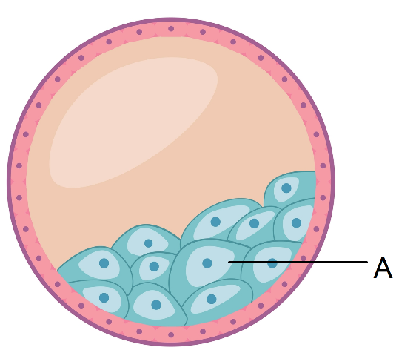

The part labelled A is a group of stem cells that will differentiate into all of the body cells that form the embryo.

(a) State the name given to the group of cells labelled ‘A’. (1 mark)

______________________________________________________________________

(b) The stem cells in part ‘A’ will initially differentiate into three layers known as the embryonic germ layers. Name two of these layers and identify one system, organ or tissue type that each layer can differentiate into. (4 marks)

One ________________________________________________________________

________________________________________________________________

Two ________________________________________________________________

________________________________________________________________

(c) Name and contrast the potency of the stem cells found in part ‘A’ compared to adult stem cells, such as those that are found in the red bone marrow. (4 marks)

______________________________________________________________________

______________________________________________________________________

______________________________________________________________________

______________________________________________________________________

______________________________________________________________________

______________________________________________________________________

______________________________________________________________________
Differentiation of stem cells occurs because of signals that influence gene expression, leading to cell specialisation. The study of the external factors that can affect gene expression is known as epigenetics.

(d) One way in which gene expression is regulated through epigenetics is due to changes in chromatin.

(i) Describe the structure of chromatin. (1 mark)

________________________________________________________________

________________________________________________________________

(ii) Name and describe one epigenetic factor that can alter chromatin and state the effect this factor has on gene expression. (3 marks)

________________________________________________________________

________________________________________________________________

________________________________________________________________

________________________________________________________________

________________________________________________________________

________________________________________________________________

________________________________________________________________

Stem cells not only have the ability to differentiate into specialised cells, but they can also repeatedly divide by mitosis to form more stem cells.

(e) Outline the major events that occur in the following phases of mitosis.

(i) Metaphase (1 mark)

________________________________________________________________

________________________________________________________________

(ii) Anaphase (2 marks)

________________________________________________________________

________________________________________________________________

________________________________________________________________

________________________________________________________________

This page has been left blank intentionally

Question 36 (13 marks)

The diagram below shows the structures of the female reproductive system.

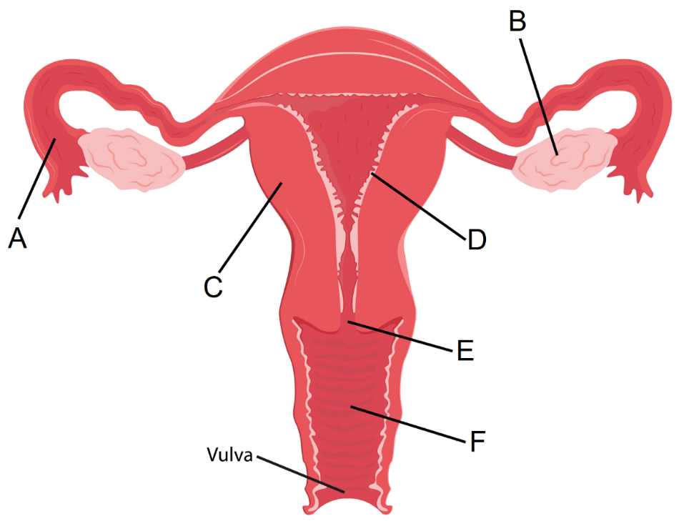

(a) Complete the table below, outlining the function of the structures indicated.
(2 marks)

Structure | Function
B
D

Gonorrhoea is a sexually transmitted infection (STI) that, if left untreated, can lead to blockages in the structure labelled ‘A’ in the diagram, and therefore infertility problems.

(b) Identify whether gonorrhoea is a viral or bacterial infection, and state the normal treatment for this STI. (2 marks)

______________________________________________________________________

______________________________________________________________________

______________________________________________________________________

(c) Suggest one way in which a gonorrhoea infection could be prevented. (1 mark)

______________________________________________________________________

______________________________________________________________________
(d) Explain how a blockage in structure ‘A’ could lead to infertility and state one other STI that could cause infertility in females. (4 marks)

______________________________________________________________________

______________________________________________________________________

______________________________________________________________________

______________________________________________________________________

______________________________________________________________________

______________________________________________________________________

______________________________________________________________________

______________________________________________________________________

______________________________________________________________________

______________________________________________________________________

(e) Name and explain one form of assisted reproductive technology (ART) that could best help overcome the fertility problems caused by a gonorrhoea infection. (4 marks)

______________________________________________________________________

______________________________________________________________________

______________________________________________________________________

______________________________________________________________________

______________________________________________________________________

______________________________________________________________________

______________________________________________________________________

______________________________________________________________________

______________________________________________________________________

______________________________________________________________________

______________________________________________________________________

______________________________________________________________________

Question 37 (14 marks)

Parturition, or birth, is the point where the foetus is expelled from the woman’s body. After the birthing process there are a number of changes that occur in the circulatory system of the newborn.

(a) The birth process is typically divided into three stages of labour. Outline any two processes/events that occur in each stage of labour. (6 marks)

First stage:

______________________________________________________________________

______________________________________________________________________

______________________________________________________________________

______________________________________________________________________

Second stage:

______________________________________________________________________

______________________________________________________________________

______________________________________________________________________

______________________________________________________________________

Third stage:

______________________________________________________________________

______________________________________________________________________

______________________________________________________________________

______________________________________________________________________

The foramen ovale is an opening between the two atria that is present in the foetal heart. It provides the blood with a different pathway compared to normal circulation through the heart.

(b) Name and describe the function of two other structures found in the circulatory system of a foetus compared to a newborn baby. (4 marks)

______________________________________________________________________

______________________________________________________________________

______________________________________________________________________

______________________________________________________________________

______________________________________________________________________

______________________________________________________________________

______________________________________________________________________

______________________________________________________________________

The foramen ovale usually closes shortly after the baby is born, however, there are cases when
the opening does not close properly.

(c) Explain the effect on normal blood flow through the heart if the foramen ovale fails to close at birth and suggest one possible symptom if this were to occur. (4 marks)

______________________________________________________________________

______________________________________________________________________

______________________________________________________________________

______________________________________________________________________

______________________________________________________________________

______________________________________________________________________

______________________________________________________________________

______________________________________________________________________

______________________________________________________________________

______________________________________________________________________

______________________________________________________________________

End of Section Two
Section Three: Extended answer 20% (40 Marks)

This section has four questions. You must answer two questions.

Questions 38 and 39 are from Unit 1. Questions 40 and 41 are from Unit 2. Answer one question from Unit 1 and one question from Unit 2.

Responses could include clearly labelled diagrams with explanatory notes; list of points with linking sentences; clearly labelled tables and graphs; and annotated flow diagrams with introductory notes.

Supplementary pages for planning/continuing your answers to questions are provided at the end of this Question/Answer booklet. If you use these pages to continue an answer, indicate at the original answer where the answer is continued, i.e. give the page number.

Suggested working time: 50 minutes.

Unit 1

Choose either Question 38 or Question 39.

Indicate the question you will answer by ticking the box next to the question. Write your answer on pages 30 – 34. When you have answered your first question, turn to page 35 and indicate on that page the second question you will answer.

Question 38 (20 marks)

To allow for efficient metabolism, cells require a constant supply of nutrients and oxygen, and need to constantly remove metabolic wastes.

(a) Explain how surface area to volume ratio, concentration gradients and the physical and chemical nature of substances can affect the exchange of materials across the cell membrane. (10 marks)

Enzymes are specialised proteins that help cells to maintain efficient metabolism. They work best in an optimum temperature between 30 to 40°C.

(b) Describe how enzymes function to optimise metabolism in the cells and explain the effect an increase in body temperature from 37°C to above 40°C can have on normal enzyme function. (10 marks)

Question 39 (20 marks)

Connective tissue is one of the four basic tissue types in the human body and can be defined based on its structure by the presence of non-cellular material known as matrix. Bone and cartilage are both examples of connective tissues that provide the body with support, protection and movement.

(a) Describe the microscopic structure of compact bone and describe the structure and function of the three different types of cartilage in the human body. (12 marks)

(b) Describe the structure and range of movement of four different types of synovial joints. (8 marks)

Question number: _______________

____________________________________________________________________________

____________________________________________________________________________

____________________________________________________________________________

____________________________________________________________________________

____________________________________________________________________________

____________________________________________________________________________

____________________________________________________________________________

____________________________________________________________________________

____________________________________________________________________________

____________________________________________________________________________

____________________________________________________________________________

____________________________________________________________________________

____________________________________________________________________________

____________________________________________________________________________

____________________________________________________________________________

____________________________________________________________________________

____________________________________________________________________________

____________________________________________________________________________

____________________________________________________________________________

____________________________________________________________________________

____________________________________________________________________________

____________________________________________________________________________

____________________________________________________________________________

____________________________________________________________________________

____________________________________________________________________________

____________________________________________________________________________
Question number: _______________

____________________________________________________________________________

____________________________________________________________________________

____________________________________________________________________________

____________________________________________________________________________

____________________________________________________________________________

____________________________________________________________________________

____________________________________________________________________________

____________________________________________________________________________

____________________________________________________________________________

____________________________________________________________________________

____________________________________________________________________________

____________________________________________________________________________

____________________________________________________________________________

____________________________________________________________________________

____________________________________________________________________________

____________________________________________________________________________

____________________________________________________________________________

____________________________________________________________________________

____________________________________________________________________________

____________________________________________________________________________

____________________________________________________________________________

____________________________________________________________________________

____________________________________________________________________________

____________________________________________________________________________

____________________________________________________________________________

____________________________________________________________________________
Question number: _______________

____________________________________________________________________________

____________________________________________________________________________

____________________________________________________________________________

____________________________________________________________________________

____________________________________________________________________________

____________________________________________________________________________

____________________________________________________________________________

____________________________________________________________________________

____________________________________________________________________________

____________________________________________________________________________

____________________________________________________________________________

____________________________________________________________________________

____________________________________________________________________________

____________________________________________________________________________

____________________________________________________________________________

____________________________________________________________________________

____________________________________________________________________________

____________________________________________________________________________

____________________________________________________________________________

____________________________________________________________________________

____________________________________________________________________________

____________________________________________________________________________

____________________________________________________________________________

____________________________________________________________________________

____________________________________________________________________________

Question number: _______________

____________________________________________________________________________

____________________________________________________________________________

____________________________________________________________________________

____________________________________________________________________________

____________________________________________________________________________

____________________________________________________________________________

____________________________________________________________________________

____________________________________________________________________________

____________________________________________________________________________

____________________________________________________________________________

____________________________________________________________________________

____________________________________________________________________________

____________________________________________________________________________

____________________________________________________________________________

____________________________________________________________________________

____________________________________________________________________________

____________________________________________________________________________

____________________________________________________________________________

____________________________________________________________________________

____________________________________________________________________________

____________________________________________________________________________

____________________________________________________________________________

____________________________________________________________________________

____________________________________________________________________________

____________________________________________________________________________

____________________________________________________________________________
Question number: _______________

____________________________________________________________________________

____________________________________________________________________________

____________________________________________________________________________

____________________________________________________________________________

____________________________________________________________________________

____________________________________________________________________________

____________________________________________________________________________

____________________________________________________________________________

____________________________________________________________________________

____________________________________________________________________________

____________________________________________________________________________

____________________________________________________________________________

____________________________________________________________________________

____________________________________________________________________________

____________________________________________________________________________

____________________________________________________________________________

____________________________________________________________________________

____________________________________________________________________________

____________________________________________________________________________

____________________________________________________________________________

____________________________________________________________________________

____________________________________________________________________________

____________________________________________________________________________

____________________________________________________________________________

____________________________________________________________________________

Unit 2

Choose either Question 40 or Question 41.

Indicate the question you will answer by ticking the box next to the question. Write your answer on the pages provided.

Question 40 (20 marks)

Contraception methods offer the opportunity for couples to plan if and when they wish to embark on the trials and tribulations that come with parenting. Although there are many different methods of contraception, one of the most effective methods in preventing fertilisation involves the use of synthetic hormones.

(a) Name and describe the function of the hormones that normally regulate the male reproductive system and the ovarian and menstrual cycle in females. (12 marks)

(b) Explain how the combined oral contraceptive pill, and emergency hormonal contraceptives (the morning-after pill), influence the hormonal control of the ovarian and menstrual cycles to prevent fertilisation. (8 marks)

Question 41 (20 marks)

Meiosis, a process that involves DNA replication, chromosome pairing and nuclear divisions, produces unique sets of gametes for reproduction. The complex process ensures there is variation in the genotypes of offspring, which will lead to variation in phenotypes.

(a) Describe the structure of DNA and explain how this structure allows for the replication of DNA. Include in your answer a brief outline of the steps involved in DNA replication.
(10 marks)

(b) Describe three processes that occur during meiosis that lead to variation. (10 marks)

End of questions
Question number: _______________

____________________________________________________________________________

____________________________________________________________________________

____________________________________________________________________________

____________________________________________________________________________

____________________________________________________________________________

____________________________________________________________________________

____________________________________________________________________________

____________________________________________________________________________

____________________________________________________________________________

____________________________________________________________________________

____________________________________________________________________________

____________________________________________________________________________

____________________________________________________________________________

____________________________________________________________________________

____________________________________________________________________________

____________________________________________________________________________

____________________________________________________________________________

____________________________________________________________________________

____________________________________________________________________________

____________________________________________________________________________

____________________________________________________________________________

____________________________________________________________________________

____________________________________________________________________________

____________________________________________________________________________

____________________________________________________________________________

____________________________________________________________________________
Question number: _______________

____________________________________________________________________________

____________________________________________________________________________

____________________________________________________________________________

____________________________________________________________________________

____________________________________________________________________________

____________________________________________________________________________

____________________________________________________________________________

____________________________________________________________________________

____________________________________________________________________________

____________________________________________________________________________

____________________________________________________________________________

____________________________________________________________________________

____________________________________________________________________________

____________________________________________________________________________

____________________________________________________________________________

____________________________________________________________________________

____________________________________________________________________________

____________________________________________________________________________

____________________________________________________________________________

____________________________________________________________________________

____________________________________________________________________________

____________________________________________________________________________

____________________________________________________________________________

____________________________________________________________________________

____________________________________________________________________________

____________________________________________________________________________
Question number: _______________

____________________________________________________________________________

____________________________________________________________________________

____________________________________________________________________________

____________________________________________________________________________

____________________________________________________________________________

____________________________________________________________________________

____________________________________________________________________________

____________________________________________________________________________

____________________________________________________________________________

____________________________________________________________________________

____________________________________________________________________________

____________________________________________________________________________

____________________________________________________________________________

____________________________________________________________________________

____________________________________________________________________________

____________________________________________________________________________

____________________________________________________________________________

____________________________________________________________________________

____________________________________________________________________________

____________________________________________________________________________

____________________________________________________________________________

____________________________________________________________________________

____________________________________________________________________________

____________________________________________________________________________

____________________________________________________________________________

Question number: _______________

____________________________________________________________________________

____________________________________________________________________________

____________________________________________________________________________

____________________________________________________________________________

____________________________________________________________________________

____________________________________________________________________________

____________________________________________________________________________

____________________________________________________________________________

____________________________________________________________________________

____________________________________________________________________________

____________________________________________________________________________

____________________________________________________________________________

____________________________________________________________________________

____________________________________________________________________________

____________________________________________________________________________

____________________________________________________________________________

____________________________________________________________________________

____________________________________________________________________________

____________________________________________________________________________

____________________________________________________________________________

____________________________________________________________________________

____________________________________________________________________________

____________________________________________________________________________

____________________________________________________________________________

____________________________________________________________________________

____________________________________________________________________________
Question number: _______________

____________________________________________________________________________

____________________________________________________________________________

____________________________________________________________________________

____________________________________________________________________________

____________________________________________________________________________

____________________________________________________________________________

____________________________________________________________________________

____________________________________________________________________________

____________________________________________________________________________

____________________________________________________________________________

____________________________________________________________________________

____________________________________________________________________________

____________________________________________________________________________

____________________________________________________________________________

____________________________________________________________________________

____________________________________________________________________________

____________________________________________________________________________

____________________________________________________________________________

____________________________________________________________________________

____________________________________________________________________________

____________________________________________________________________________

____________________________________________________________________________

____________________________________________________________________________

____________________________________________________________________________

____________________________________________________________________________

____________________________________________________________________________
Supplementary page

Question number: _______________

____________________________________________________________________________

____________________________________________________________________________

____________________________________________________________________________

____________________________________________________________________________

____________________________________________________________________________

____________________________________________________________________________

____________________________________________________________________________

____________________________________________________________________________

____________________________________________________________________________

____________________________________________________________________________

____________________________________________________________________________

____________________________________________________________________________

____________________________________________________________________________

____________________________________________________________________________

____________________________________________________________________________

____________________________________________________________________________

____________________________________________________________________________

____________________________________________________________________________

____________________________________________________________________________

____________________________________________________________________________

____________________________________________________________________________

____________________________________________________________________________

____________________________________________________________________________

____________________________________________________________________________

____________________________________________________________________________
Supplementary page

Question number: _______________

____________________________________________________________________________

____________________________________________________________________________

____________________________________________________________________________

____________________________________________________________________________

____________________________________________________________________________

____________________________________________________________________________

____________________________________________________________________________

____________________________________________________________________________

____________________________________________________________________________

____________________________________________________________________________

____________________________________________________________________________

____________________________________________________________________________

____________________________________________________________________________

____________________________________________________________________________

____________________________________________________________________________

____________________________________________________________________________

____________________________________________________________________________

____________________________________________________________________________

____________________________________________________________________________

____________________________________________________________________________

____________________________________________________________________________

____________________________________________________________________________

____________________________________________________________________________

____________________________________________________________________________

____________________________________________________________________________
Supplementary page

Question number: _______________

____________________________________________________________________________

____________________________________________________________________________

____________________________________________________________________________

____________________________________________________________________________

____________________________________________________________________________

____________________________________________________________________________

____________________________________________________________________________

____________________________________________________________________________

____________________________________________________________________________

____________________________________________________________________________

____________________________________________________________________________

____________________________________________________________________________

____________________________________________________________________________

____________________________________________________________________________

____________________________________________________________________________

____________________________________________________________________________

____________________________________________________________________________

____________________________________________________________________________

____________________________________________________________________________

____________________________________________________________________________

____________________________________________________________________________

____________________________________________________________________________

____________________________________________________________________________

____________________________________________________________________________

____________________________________________________________________________
Supplementary page

Question number: _______________

____________________________________________________________________________

____________________________________________________________________________

____________________________________________________________________________

____________________________________________________________________________

____________________________________________________________________________

____________________________________________________________________________

____________________________________________________________________________

____________________________________________________________________________

____________________________________________________________________________

____________________________________________________________________________

____________________________________________________________________________

____________________________________________________________________________

____________________________________________________________________________

____________________________________________________________________________

____________________________________________________________________________

____________________________________________________________________________

____________________________________________________________________________

____________________________________________________________________________

____________________________________________________________________________

____________________________________________________________________________

____________________________________________________________________________

____________________________________________________________________________

____________________________________________________________________________

____________________________________________________________________________

____________________________________________________________________________

Spare grid



ACKNOWLEDGEMENTS

Question 14–16 Adapted from: Blueringmedia (n.d) [Anatomy of the male reproductive system diagram]. Retrieved from https://www.dreamstime.com/stock-image-anatomy-male-reproductive-system-image37867851

Question 28 Adapted from: Designua (n.d) [Tissue types. Connective, muscle, nervous, and epithelial cells]. Retrieved from https://www.dreamstime.com/tissue-types-connective-muscle-nervous-epithelial-close-up-cells-different-tissue-anatomical-fiber-parts-epithelium-bone-image205375511

Question 32 Adapted from: Alila07 (n.d.) [Blood clotting process]. Retrieved from https://www.dreamstime.com/royalty-free-stock-images-blood-clotting-process-image27393999#_

Question 32 Adapted from: Wikimedia Commons (2019). Retrieved from https://commons.wikimedia.org

Question 33 Adapted from: Georghiou, C. (n.d.) [Digestive Tract System Illustration]. Retrieved from https://www.dreamstime.com/stock-illustration-digestive-tract-system-illustration-human-alimentary-canal-labels-black-white-image84348384

Question 35 Adapted from: Bisma, B. (n.d.) [Flat illustration of human blastocyst cell]. Retrieved from https://www.dreamstime.com/flat-illustration-human-blastocyst-cell-image223805106

Question 36 Adapted from: Voinau, P (n.d.) [Female reproductive system detailed anatomy]. Retrieved from https://www.dreamstime.com/stock-illustration-female-reproductive-system-detailed-anatomy-vector-medical-illustration-image71116722

